**Database Questions**

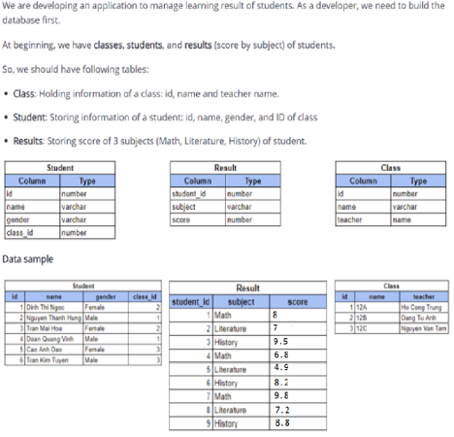

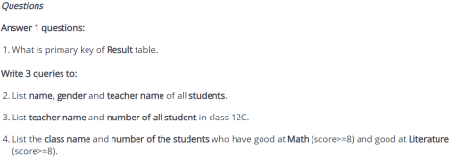**JPA/Hibernate Questions**

Using DDL, DML design database and insert test data for tables then handle questions below using JPA/Hibernate in Eclipse project

1. List all student by class id

2. List the class name and number of students, name of students who have Math point >= 8 and Literature >= 8

3. Count/Statistic amount of students per class

4. Find students who have average of points >= 8.2

5. Find/statistic students who have max average of point in their class

--------------------------------------------------------------------------------------------------------------------- How to submit contests

Step 1 🡪 Create **lesson18-hoten.sql** in sql workbench, using DDL, DML to design database and handle **Database Questions**

Step 2 🡪 Create project **lesson18-hoten** in Eclipse then start exam there

Step 3 🡪 Copy **lesson18-hoten.sql** and paste to **lesson18-hoten** folder 🡪 push to lesson18- exam

Step 4 🡪 Execute **JPA/Hibernate Questions**

--------------------------------------------------------------------------------------------------------------------- Submit branch: lesson18-exam